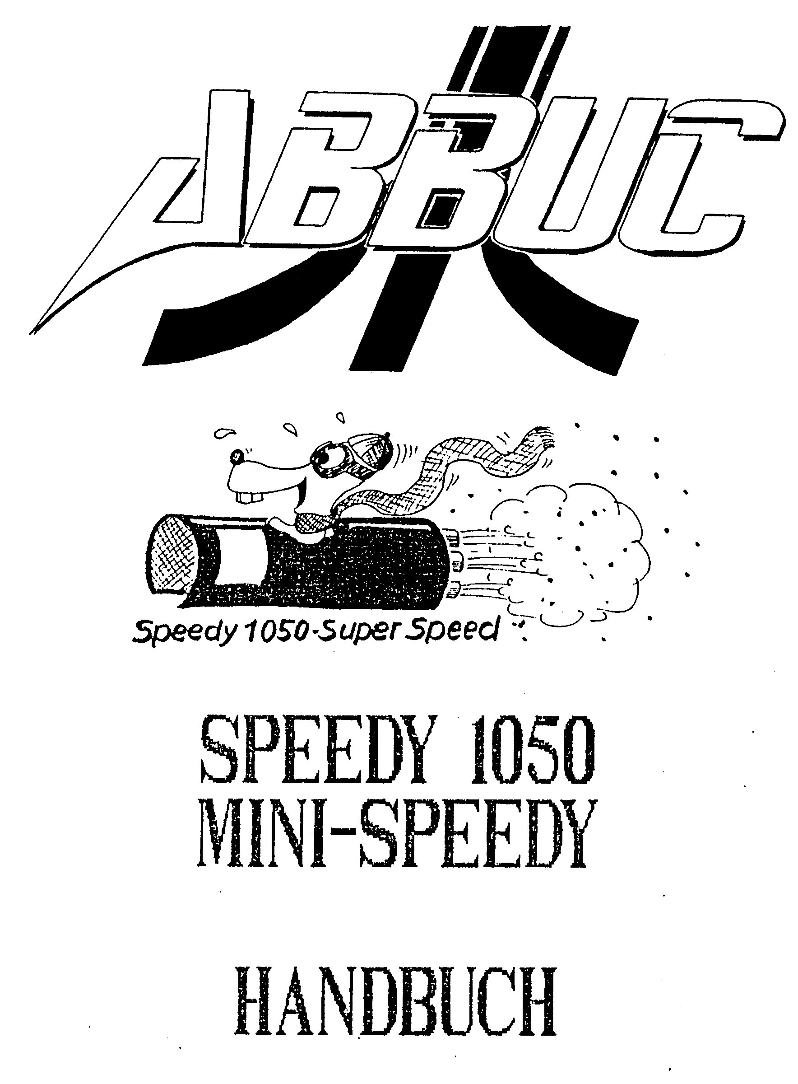

SPEEDY 1050 / mini SPEEDY MANUAL (C) ABBUC

ATTENTION IMPORTANT! READ THIS !!

In order to install the SPEEDY 1050/Mini-SPEEDY into your drive you have to open the drive case. Thereby you may lose any warranty of ATARI or the warranty of the dealer/vendor, you purchased the drive. We cannot be held responsible for any damage done to your drive nor do we replace any broken hardware. In the case of doubt you give the SPEEDY 1050 / Mini-SPEEDY to us (CompyShop, now days ABBUC !) to properly insert it into your 1050. We take some extra costs for this service that are well worth paying, than probably damaging your hardware. If you think you are capable of inserting the extension yourself, position yourself the following tools:

1. Screwdriver
2. Normal screwdriver (small)
3. Flat-nose pliers
4. Side cutter

In order to install the SPEEDY 1050/mini-SPEEDY into your drive first remove all cables and patch cords from your drive. Then turn it upside down, so now are looking at the lower surface of your drive. There are six screws. Unscrew these screws and put them aside (in a safe place!). Now you turn your drive assembly carefully, but with caution! So you will not lose any parts. Now you can take away/off the upper case part together with the brown front plate. Put both parts aside. The drive assembly mechanic lies loosely on four ... (Stuetzen/Pfeilern).
Raise the mechanic in front and you will recognize a quantity of cables, which go from the mechanic to the basic plate. Normally it is not necessarily to take off the plugs, you can however remove them from the basic plate, if you like. Caution: Remember the correct plug-ins, please or write them down!!

Then remove the four black rubber plugs, which the drive assembly mechanic normally rests upon and keep them in a safe place. You will need them afterwards. The drive assembly electronics is held in the front case by two plastic noses. They are on each side of the front case (right and left). They prevent the floppy board from moving away. Bend the noses carefully to the side and thereby raise the board.

If you took this hurdle, you can lift the board without any further difficulties from the lower case. You should pay as well some attention to it. Now you may recognize the silver metal screen, that hides the ROM chips under it. This screen consists of two parts, which are connected with four latches at the lower surface of the floppy board. Bend these four noses with the flat-nose pliers to the side and take the metal screen off (we do not need it anymore!).

In the center of the plate, where the screen was before, you will now see five big IC's,
Here is the list of IC’s from left to the right:

Disc controller 2793 or 2797 (40 pins)
ROM or EPROM with the operating system (24 poles)
CCU 6507 (28 pins)
RAM 68lO (24 pins)
PIO 6532 (40 pins)

Lift now (with the help of a screwdriver) the ROM (U10) and the CCU (U9) from their bases and put you them aside. These IC`s are not needed any longer!! Into free the space of the CCU (U9), put the SPEEDY 1050 plate. Owners of a mini SPEEDY should put the plate facing to the left here. Do not put in the plate in the wrong way!!
(The ROM (with the sticker) and RAM (with the designation 6264) should face to the left!!)

If you have one of the older BIG SPEEDY board you should fit the high-standing silver quartz by the cutout in the plate look. Pay some attention here!! With some drive assemblies the plate itself somewhat heavily puts in. But don't be frightened, the Speedy therefore fits better and tougher in its place...

In the power amplification for the serial signals, there are four condensers, which affect the pulse slope with the higher SIO rate. Thus, you have to remove them. Take a side cutter and simply cut the following condensers off: C56 - C57 - C58 - C61
You find these condensers on the 1050 base plate in the back right, besides the three big Elkos. Also, consider the design in the fitting instruction (page 5). It is not necessary (by the way) to re-install these four condensers again, if you decide to remove the SPEEDY 1050/mini-SPEEDY. The missing condensers will not affect the SIO rate, it becomes safer thereby. If you should own two drive assemblies, also remove these four condensers there, even if no SPEEDY is in this drive assembly.

Next, you should do a function control and set the speed adjustment. Connect the power to the drive assembly. If everything still functions correctly, after you switch on the drive and the power control light should light up. Now close the flap of the drive assembly without a disk. The busy lamp should light up and the write/read head should move a few steps to center. If all functions of your drive work as described here, you can continue testing the speed adjustment. If something is wrong or does not work, go through all steps again and particularly test the contacts which connect the SPEEDY 1050/mini-SPEEDY with the CPU BASE.

In order to do the speed adjustment, insert your provided SPEEDY SYSTEMDISK into the drive assembly and switch on the computer. After a short load time the Speedy software menu appears. choose the speed adjustment by pressing one for the SPEEDY MENU selections. Press ‘1’ and you will arrive at the SPEEDY 1050 test program.

Pressing the key ‘4’ starts the speed test. You get the rounds per minute (RPM) measure indicated, the drive should have (288) and the real RPM measure it actually has (<=> 288). The optimal speed is 288 RPM. Because the Drive assembly mechanics are not always rotating (properly) disks with the same measure, the speed may not always be constant and speed fluctuations up to 0.6 RPM may appear. This is normal and should not worry you. With the automatic controller VR2 you should stop the number of revolutions, so the speed adjusts between 287.5 and 288.5 RPM. The speed may be better adjusted to somewhat less than more. The speed adjuster is directly behind the drive assembly chassis on the left side of the basic plate (consider the instruction). NOTE: The control range is very big and minimum adjustment may already cause a big speed variance...

Owners of a SPEEDY 1050 with TRACK LED should insert now their indicator plate at the front of their drive assembly. We do not have general clues here, just look for the best place for the LED and cut yourself a suitable cutout into the front plate. You can also test your Track LED with the Speedy test. First, choose the Speedy menu, then the Speedy test and press three to test the LED. You will see the test onscreen (with default numbers) and simultaneously on the Track LED, besides you will hear the "Error" indicating buzzer making some noise...

Before you assemble your floppy disk drive again, you can also install two more switches into your drive assembly. The first switch is a write lock switch, with its assistance you can write onto Disk backsides without cutting it. The second switch may help you to place the SPEEDY to slow
Mode, if you want to load copy protected software for example. This is the same as the Happy enhancements "unhappy" mode. The installation of these two switches is very easy and can easily be made. Just concern the instruction manual on page 5...

SPEEDY S, SPEEDY D, SPEEDY DS
The sector copier in the SPEEDY S (DS) or the DOS in the SPEEDY D boot up if you switch on the computer and simply leave the drive assembly flap open, Since the SPEEDY DS includes both programs, you have another switch so you can always choose which program you want to boot (DOS or Sector copier). Finally, we reached the end of the SPEEDY 1050 (mini SPEEDY) installation manual. We hope, everything works well now and then and you will enjoy your Speedy 1050 enhancement.

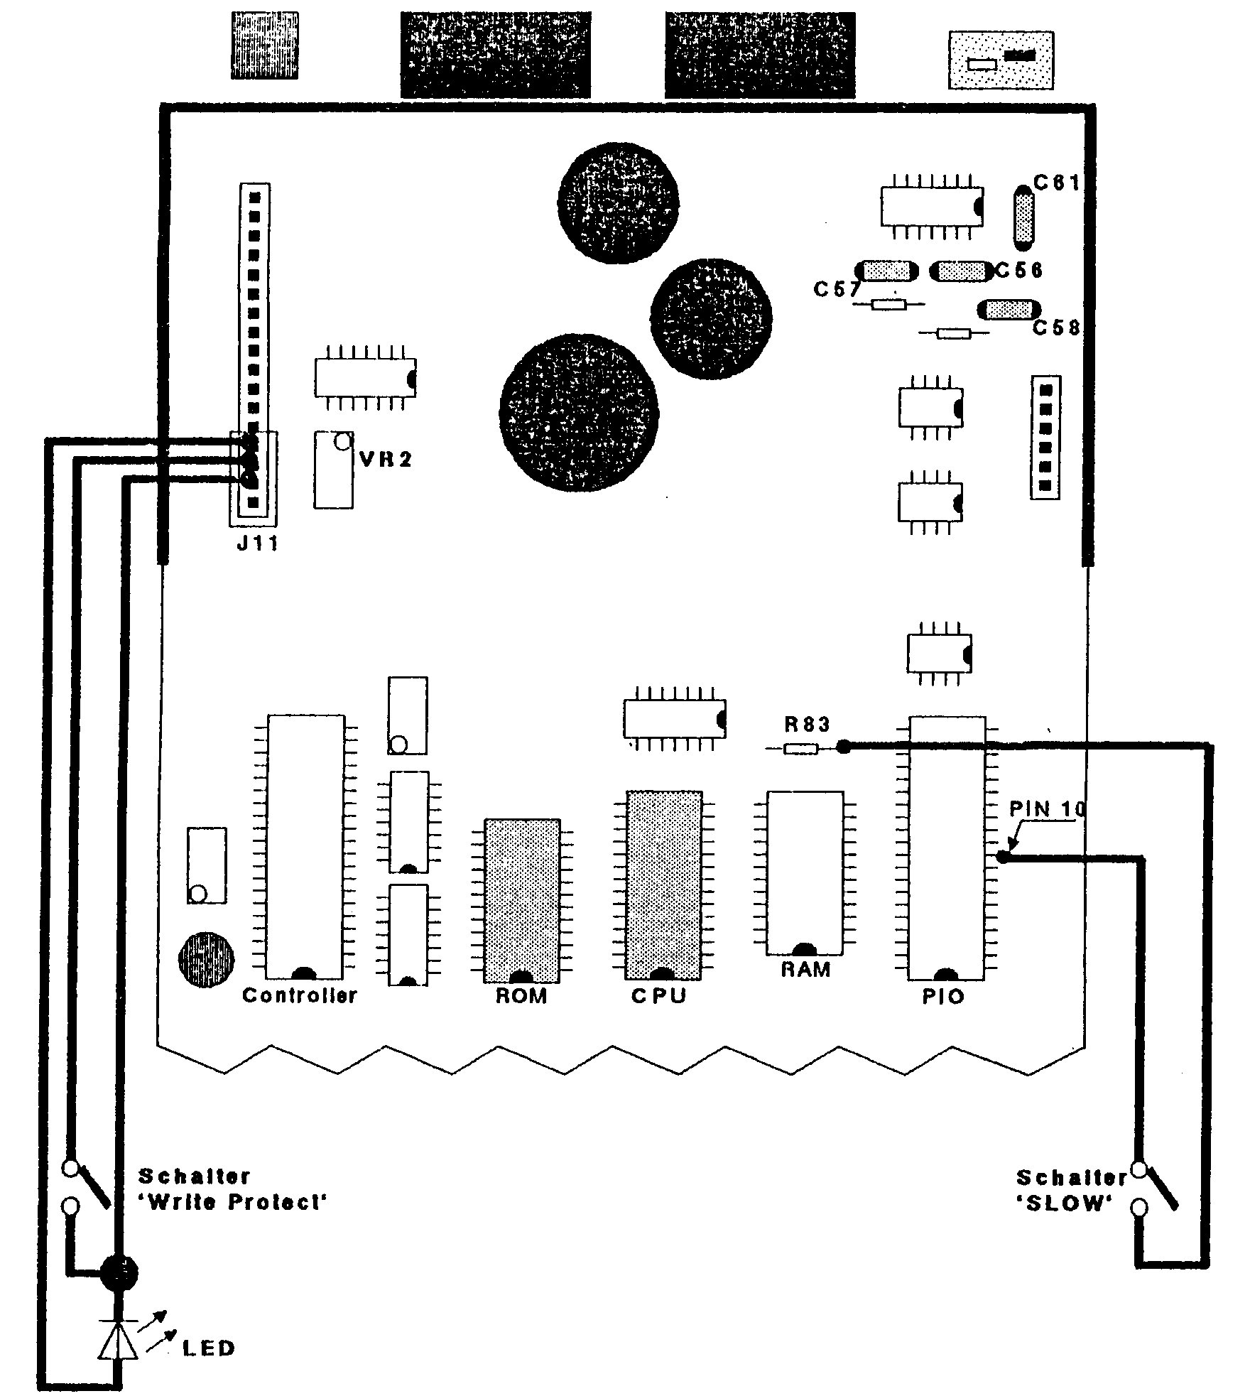

SPEEDY SYSTEM DISK:
Insert the system disk into your drive assembly and switch on your Atari computer. The OPTION key needs not to be held. After few seconds, the MAINMENU appears with several points of selection.

Here is now a short description of all Menu options and their handling.

MAIN MENU:

[Option 1: SPEEDY MENU (V. 1.x)]
Here it is indicated how many SPEEDY drive assemblies are attached.
SLOW switched Speedy drives assemblies are not recognized. With the key ' D ' you can choose, which drive to be addressed.

Speedy Test:

1. SPEEDY RAM TEST
The 8k-Byte RAM on the SPEEDY 1050 (mini SPEEDY) is tested here.

2. SPEEDY ROM TEST
The ROM of the SPEEDY 1050 (mini SPEEDY is tested here.

3. INDICATOR TEST (TRACK LED)
Tests the display (TRACK LED) and the buzzer of a SPEEDY 1050 with Track LED.

4. SPEED TEST
The number of revolutions/rounds of the drive motor is tested here.

FUNCTION CONTROL

With the keys 1-6 you set the appropriate control bit for the chosen functions. The control bits could merely be re-setting with the key ' R '.
The functions of the control bit in detail:
1 - When a write/read error occurs, the buzzer makes a warning tone.
Works only with a SPEEDY T.
2 - Do not switch the driving motor off with command $51 (all sectors from internal Buffer are written immediately ) .
3 - With command $20 (special format instruction) do not write the boot and directory sectors.
4 - Formats without VERIFY. Thus formatting will be done in approx. 9 seconds. Caution with cheap disks!!

5 - Represent TRACK LED in Hexadecimal form.
6 - Display a write/read error (and the ERROR status) in hexadecimal form on the Track LED. Can be used together with function 1 and is indeed very handy to find copy protected sectors... (or copy protections). Works only on a SPEEDY T.

The complete control byte is indicated on the screen. After you press the key' W ' the byte is sent to the drive assembly.

SLOW MODE CONTROL:

With the key ' D ' you can choose the SPEEDY drive and which one should be adjusted here. With the Keys 1-4 you set again the individual status bit for the following functions:
1 - Sector read: slowly. The sectors are not read with any TRACK/Cache buffer of the Speedy, but are read individually and sent individually to the computer, as with a normal drive assembly without enhancement.
2 - Sector write slowly. The sectors are not written with any track/Cache buffer, but are written individually...
3 - COM $57 with Verify. DOS 2,DOS 2.5 and DOS 3 use the instruction 57 to write sectors with verify. Because this takes longer than necessary, verify is normally disabled in Speedy enhancements. You can however enable write with verify here, if you like...
4 - Drive assembly in SLOW mode. This means, that all auxiliary instructions, which are unavailable with the normal 1050 OS are ignored further on. It also means, the drive now behaves like a slow mode 1050. This can necessary, if you want to load in any copy protected software on a SPEEDY drive. If the Speedy should work with higher speed (SIO rate) after the activation of this status bit, you have to turn off and back on again the drive assembly.

With the key 'R', all status bits are re-setting. With a key press of the key ‘W’, you send the adjusted status to the SPEEDY drive...

DRIVE ASSEMBLY = ORIGINAL:

With some copy-protected programs, it is necessary, to turn your SPEEDY 1050/mini SPEEDY into a normal 1050 drive again. With some other Floppy speeders you have to remove the enhancement to do this. This is not necessary with the SPEEDY. With the help of this function the SPEEDY OS is modified in such a way, so a SPEEDY 1050 (mini SPEEDY) drive behaves like a normal 1050 without enhancement. Thus, a program cannot determine now, whether an enhancement is
installed in the drive assembly or not. The SPEEDY 1050 (mini SPEEDY) can restart again, by simply turning off your drive and then back on again...

Main Menu Option 2 - SPEEDY BACKUP
This program serves for copies from copy-protected software. Approx.80% of all protected (SINGLE Density) disks in the trade could be copied (once upon along ago!). The operation is self-explanatory, but you cannot copy these disks:
1) Tracks with more than 19 sectors per TRACK.
2) Sectors with changing data.
3) MEDIUM Density disks.

The status of a TRACK that can be copied is indicated on the screen. The individual status messages mean in detail:
. = normal TRACKS with 18 sectors.
- = on the TRACK are less than 18 sectors.
+ = on the TRACK are more than 18 sectors.
X = TRACK is unformatted.
U = format uncommon or too many sectors on the Track.
The copied disk often will not work...
E = an error occurred while copying

Main Menu Option 3 - SPEED INIT
You find the German guidance for this program in the MAIN MENU under the POINT 4 - "Anleitung zum INIT." This is a gamedos for all *.BAS, *.BIN,
*.COM and *.OBJ files. It works with Single, Medium/Enhanced and Double Density Disks. Do the following:
1) Load the program and format/init a disk,
2) Use DOS or a file copier to copy all files onto this disk,
3) Lock all loadable files,
4) re-run the gamedos program and name all the copied files with full gamedos names (up to 32 chars.),
5) Now you can boot your new gamedos disk...

Main Menu Option 5 - SECTOR COPIER:
This is the standard copier for unprotected disks in all three diskette formats (S/M/D). It also works on drives, without any enhancement. All COMPY SHOP RAM disks and the RAM disk of an 130 XE Atari will be supported. Thus, it is for example possible to copy a DOUBLE Density disk in one passage. The operation of the sector copier is self-explanatory: Use [Start], [Select] and [Option] to operate it. Press [Option] again to do another copy of the same disk, press [Select] to continue reading, if an error or any disk protection appears...

Main Menu Option 6 - DISK MAPPER:
With this program, you can get an overview of a disk. Full and empty sectors are as well indicated as defective or no existing sectors. The sequence of the sectors present at a TRACK can be indicated. You will find the meaning of the individual status values in the program of the German Menu point INFORMATIONEN.

Main Menu Option 7 - _HSS COPIER:
At present, this is the quickest sector copier for the SPEEDY 1050/mini SPEEDY drives. You find a description of this program in the MAIN MENU
POINT 8 (German) "Anleitung HSS COPIER". This copier does not work on all 1050 drives. This is because of the construction unit tolerance of the different1050 electronics. If you should have problems with this copier, please inquire the ABBUC Floppy-Doc (Erhard Puetz), he perhaps can help you quickly and give some tips. As with the normal Sector-Copier, use [Start], [Select] and [Option], to operate this program.

Now, here follows the description of the permanent Speedy Drive SIO commandos. Since I am not a programmer and do not have any knowledge about this, I will not translate this long section... sorry !!

DESCRIPTION OF THE PERMANENT DRIVE ASSEMBLY INSTRUCTION
The list of the SIO commands follows for the SPEEDY 1050 (mini SPEEDY).
This list is particularly for the interested machine language programmer meant,
who programs its SPEEDY 1050 (MiniSPEEDY) itself m?chte.
COMMAND is the value, which is before call of the SIO routine $$E459 ()
in the storage location $302. AUX1 and AUX2 entprechen the values, which
are in the storage locations $30a (Low byte) and $30b (High byte). With
some instructions AUX1 and AUX2 are not used and d?rfen arbitrary values to
assume.
COMMAND: $52
FUNCTION: Sector read
AUX1: Sector number Low byte
AUX2: Sector number High byte
DESCRIPTION: Depending upon Density 128 or 256 bytes are sent to the
computer. With the sectors 1-3 also with DOUBLE Density only 128 bytes
are sent.
REMARK: Sector number 0000 selects the Zero page RAM in the SPEEDY 1050
> >> (mini SPEEDY). With sectors more gr??er $8000 that is selected RAM or
> the
> >> ROM.
> >> ($8000-9fff = RAM / $$C000 or $$E000-FFFF = ROM)
> >> COMMAND: $50
> >> FUNCTION: Sector write without Verify
> >> AUX1: Sector number Low byte
> >> AUX2: Sector number High byte
> >> DESCRIPTION: The drive assembly expects 128 or 256 bytes depending upon
> >> Density. Sectors 1-3 are always 128 bytes long.
> >> REMARK: The SPEEDY main memory $8000 - $9fff can be described
> >> purposefully. Zeropage (sector 0000) cannot be described.
> >> COMMAND: $57
> >> FUNCTION: Sector write with Verify
> >> AUX1: Sector number Low byte
> >> AUX2: Sector number High byte
> >> DESCRIPTION: Like instruction $50
> >> REMARK: Like instruction $50. Starting from the SPEEDY version 1,4
> SPEEDY
> >> internal is switched off with this command of the Verify. In order to
> >> permit the Verify again, mu? with instruction $4b the bit 2 in the
> >> configuration byte to be set.
> >>
> >> Page 10
> >> SPEEDY 1050 / mini SPEEDY MANUAL (C) ABBUC
> >>
> >> COMMAND: $53
> >> FUNCTION: Drive assembly status determine
> >> AUX1: Does not use
> >> AUX2: Does not use
> >> DESCRIPTION: The drive assembly sends 4 bytes, which contain the status
> of
> >> the inserted disk and the last diskette operation.
> >> Byte 1: DRIVE STATUS
> >> Bit 0 - COMMAND FRAME ERROR
> >> Bit 1 - CHECKSUM ERROR
> >> Bit 2 - OPERATION ERROR
> >> Bit 3 - WRITE PROTECT
> >> Bit 4 - ENGINE ON
> >> Bit 5 - DOUBLE DENSITY
> >> Bit 6 - unused
> >> Bit 7 - BINARILY (MEDIUM) DENSITY
> >> Byte 2: CONTROLLER STATUS
> >> Bit 0 - BUSY
> >> Bit l - DRQ
> >> Bit 2 - Lost data
> >> Bit 3 - (carriage return character) ERROR
> >> Bit 4 - RECORD EMERGENCY FOUND
> >> Bit 5 - RECORD TYPE
> >> Bit 6 - WRITE PROTECT
> >> Bit 7 - EMERGENCY READY
> >> Byte 3: Time Out value fur format disk ($$E0)
> >> Byte 4: unused (always 0)
> >> COMMAND: $21
> >> FUNCTION: Format disk (SINGLE/DOUBLE }
> >> AUX1: Function byte 1
> >> AUX2: Function byte 2
> >> DESCRIPTION: This command is used, in order to format disks in single
> or
> >> double Density (720 sectors). The Density format is stopped by a
> previous
> >> $4f-befehl (drive assembly configuration). One does not configure the
> >> drive assembly after switching on on, in SINGLE Density one formats
> >> automatically. Is to be formatted in medium Density (1040 sectors), mu?
> >> are in function byte 1 the value $11 and in function byte 2 the value 4.
> >> The drive assembly sends to that formats depending upon Density 128 or
> 256
> >> bytes to the computer. The first two bytes always are after successful
> >> formatiern $$FF.
> >>
> >> Page 11
> >> (C) ABBUC SPEEDY 1050 / mini SPEEDY MANUAL
> >>
> >> COMMAND: $22
> >> FUNCTION: Format disk (MEDIUM)
> >> AUX1: Does not use
> >> AUX2: Does not use
> >> DESCRIPTION: To format this command used around disks in l050 dual
> Density
> >> (MEDIUM = 1040 sectors). Always 128 bytes are sent to the computer.
> The
> >> first two bytes always are after erFolgreichem formatiern $$FF.
> >> This were the standard instruction normal 1050. All following
> instructions
> >> do not k?nnen with a SLOW switched SPEEDY to be addressed.
> >> COMMAND: $20
> >> FUNCTION: Automatic format
> >> AUX1: Function byte 1
> >> AUX2: Function byte 2
> >> DESCRIPTION: The drive assembly only the instruction is given to format
> >> to. It is zur?ckgemeldet immediately a ' Complete '. With this
> >> instruction all three formats k?nnen to be generated. The gew?nschte
> >> density mu? before with the instruction $4f (configure to drive
> assembly)
> >> to be adjusted. Is to be formatted in medium Density (1040 sectors),
> mu?
> >> in function byte 1 the value S11 and in function byte 2 the value 4 find
> in
> >> Write protect zur?ckgemeldet itself immediately. Errors with do not
> format
> >> k?nnen the computer to be announced, since no data are zur?ckgesendet
> after
> >> Befehlsausf?hrung. Abh?ngig of the DRIVE/DISPLAY status is written
> >> automatically after that to format the vtoc (DOS 2/2.5/BIBO-DOS
> compatibly)
> >> and 3 boat sector.
> >> COMMAND: $3f
> >> FUNCTION: SIO Geschwindigkeitsbyte determine
> >> AUX1: Does not use
> >> AUX2: Does not use
> >> DESCRIPTION: A byte is sent to the computer, which contains the upper
> >> carrying speed in High speed. This byte is ben?tigt f?r the HIGH speed
> SIO
> >> routine and betr?gt with the SPEEDY 1050 (mini SPEEDY) normally 09.
> >>
> >> Page 12
> >> SPEEDY 1050 / mini SPEEDY MANUAL (C) ABBUC
> >>
> >> COMMAND: $4e
> >> FUNCTION: Drive assembly configuration pick out
> >> AUX1: Does not use
> >> AUX2: Does not use
> >> DESCRIPTION: The 12 bytes of the configuration table are sent to the
> >> computer.
> >> Byte 1 - Number of the TRACK (40)
> >> Byte 2 - Step rate (1)
> >> Byte 3 - Sector/TRACK High (0)
> >> Byte 4 - Sector TRACK Low (18/26)
> >> Byte 5 - Number of K?pfe (0)
> >> Byte 6 - Recording format (0=FM/4=MFM)
> >> Byte 7 - Byte/sector High (1=256/0=128)
> >> Byte 8 - Byte/sector Low (0=256/128=128)
> >> Byte 9 - Drive assembly actively (255)
> >> Byte 10 - unused (0)
> >> Byte 11 - unused (0)
> >> Byte 12 - unused (0)
> >> COMMAND: $4f
> >> FUNCTION: Configure to drive assembly
> >> AUX1: Does not use
> >> AUX2: Does not use
> >> DESCRIPTION: This instruction is used, in order to stop the drive
> assembly
> >> f?r the n?chsten formatting instruction. The drive assembly expects 12
> >> bytes, which correspond exactly to the sequence of the previous
> instruction
> >> ($4e) m?ssen.
> >> COMMAND: $51
> >> FUNCTION: Recording procedure terminate
> >> AUXl: Function byte 1
> >> AUX2: Function byte 2
> >> DESCRIPTION: After each write instruction the drive assembly waits
> approx.
> >> 2
> >> Seconds to the data from the Trackbuffer on those
> >> Disk to be written. This becomes by that
> >> Instruction $51 accelerates. All data in the Trackbuffer
> >> unverz?glich on the disk are written and
> >> abh?ngig of the DRIVE/DISPLAY status ($44) the engine
> >> after recording procedure immediately stopped. Are
> >> both function byte $$FF becomes auxiliaryborrowed all
> >> Sectors from the Cache Buffer on the disk written.
> >>
> >> Page 13
> >> (C)ABBUC SPEEDY 1050 / mini SPEEDY MANUAL
> >> _
> >>
> >> COMMAND: $44
> >> FUNCTION: DRIVE/DISPLAY attitude
> >> AUX1: Configuration byte
> >> AUX2: Does not use
> >> DESCRIPTION: The value in AUX1 sets the DRIVE/DISPLAY status byte in the
> >> drive assembly. This byte can be picked out more?ber no instruction
> >> directly, so there? all bits to be always set correctly m?ssen.
> >> Bit 0 - Bell with ERROR permit
> >> Bit 1 - unused
> >> Bit 2 - unused
> >> Bit 3 - Do not switch $51 off engine with COM
> >> Bit 4 - With COM $20 vtoc and BOAT do not write
> >> Bit 5 - Format without Verify
> >> Bit 6 - TRACK announcement in hexadecimal
> >> Bit 7 - ERROR - announcement switch on
> >> COMMAND: $4b
> >> FUNCTION: Slow/Fast configuration
> >> AUX1: Configuration byte
> >> AUX2: Does not use
> >> DESCRIPTION: With the value in AUX1 the DRIVE Slow Statusbyte of the
> drive
> >> assembly is beeinflu?t. This byte can be picked out more?ber no
> >> instruction directly, so there? all bits to be set correctly m?ssen.
> >> Bit 0 - READ sector slow
> >> Bit 1 - Write sector slow
> >> Bit 2 - Command $57 verify switch on
> >> Bit 3 - Drive assembly vollst?ndig in slow mode
> >> Bit 4 - unused
> >> Bit 5 - Cache Buffer switch off
> >> Bit 6 - 1 TRACK slow (after TRACK change 0)
> >> Bit 7 - 1 disk slow (after diskette change 0)
> >> COMMAND: $4c
> >> FUNCTION: Direct branch instruction without R?ckmeldung
> >> AUX1: Branch address Low byte
> >> AUX2: Branch address High byte
> >> DESCRIPTION: The microprocessor in the drive assembly is veranla?t by
> this
> >> instruction to jump directly to the storage location which is in AUX1 and
> >> AUX2. The drive assembly does not give a message so there to the
> computer
> >> zur?ck? a R?ckmeldung from the program to be given mu?, to that the
> >> processor jumped.
> >>
> >> Page 14
> >> SPEEDY 1050 / mini SPEEDY MANUAL (C) ABBUC
> >>
> >> COMMAND: $4d
> >> FUNCTION: Direct branch instruction with re-call
> >> AUX1: Branch address Low byte
> >> AUX2: Branch address High byte
> >> DESCRIPTION: This instruction resembles the preceding up to the
> >> difference, there? the drive assembly before running of the program
> a
> >> jerk message (Complete) to the computer sends.
> >> COMMAND: $41
> >> FUNCTION: Command table shorter or longer
> >> AUX1: Does not use
> >> AUX2: Does not use
> >> DESCRIPTION: The drive assembly expects 3 bytes of the computer. The
> 1.
> >> Byte is the new command. 2. and 3. Byte is the start address the?ber
> new
> >> command reached program in the low/high byte format. If the new
> instruction
> >> already is in the command table, this is provided with the new start
> >> address. The start address 0000 is the instruction from the command
> table
> >> is gel?scht.
> >> COMMAND: $68
> >> FUNCTION: Determine for a long time the SIO routine
> >> AUX1: Does not use
> >> AUX2: Does not use
> >> DESCRIPTION: With this instruction the long one of the SIO routine is
> >> determined, which is loaded with the instruction $69 from the drive
> >> assembly into the computer. The drive assembly sends 2 bytes, which
> >> contain the L?nge (low/high).
> >> COMMAND: $69
> >> FUNCTION: SIO routine to the computer send
> >> AUX1: Relokator - address low byte
> >> AUX2: Relokator - address high byte
> >> DESCRIPTION: This instruction sends the High speed SIO routine in from
> the
> >> instruction the $68 determined long ones to the computer. This routine
> is
> >> already relokiert in the drive assembly to the start address, which is
> in
> >> AUX1 and AUX2.
> >>
> >> Page 15
> >> (C) ABBUC SPEEDY 1050 / mini SPEEDY MANUAL
> >>
> >> COMMAND: $60
> >> FUNCTION: TRACKS write
> >> AUX1: TRACK initial sector low byte
> >> AUX2: TRACK initial sector high byte
> >> DESCRIPTION: The complete data f?r a TRACK are written with this
> >> instruction on the disk or into the Trackbuffer. The number of bytes
> which
> >> can be beaver-carried is calculated by the number of sectors times the
> >> bytes per sector. Because of the very difficult Timings this
> instruction
> >> functions only into more normally?bertragungsrate.
> >> COMMAND: $62
> >> FUNCTION: TRACKS read
> >> AUX1: TRACK initial sector low byte
> >> AUX2: TRACK initial sector high byte
> >> DESCRIPTION: Read a complete TRACK with an instruction of the disk or
> from
> >> the Trackbuffer. The number to expecting bytes is calculated by the
> number
> >> of sectors times the bytes per sector.
> >>
> >> Page 16
> >> SPEEDY 1050 / mini SPEEDY MANUAL (C) Compy Shop
> >>
> >> At the Schlu? now still another example, how these instructions are
> used.
> >> With this small demo program the High speed routine of the SPEEDY can be
> >> loaded into the computer. This program with the BIBO ASSEMBLER was
> >> written.
> >> 00010 LI OFF
> >> 00020 OR $4000
> >> 00030 __________________
> >> 00040 ADDR = $5000 ADDRESS F?R THE SIO ROUTINE
> >> 00050 _______________
> >> 00060 LDA #$31 BUS ID
> >> 00070 STA $0300
> >> 00080 LDA #1 DRIVE NUMBER = 1
> >> 00090 STA $0301
> >> 00100 LDA #$68 COMMAND $68
> >> 00110 STA $0302
> >> 00120 LDA #$40 STATUS FOR DATA VINTAGES
> >> 00125 STA $0303
> >> 00130 LDA #8
> >> 00140 STA $0304 ADDRESS F?R LOW L?NGENBYTE
> >> 00150 STA $0306 VALUE FOR TIMEOUT APPROX. 8 SEC..
> >> 00160 LDA #3
> >> 00170 STA $0305 ADDRESS F?R HIGH L?NGENBYTE
> >> 00180 LDA #2
> >> 00190 STA $0308 2 BYTES VINTAGES
> >> 00200 LDA #0
> >> 00210 STA $0309
> >> 00220 JSR $$E459 RE-ENTRY POINT OF THE SIO ROUTINE IN THE OS
> >> 00230 BMI ERROR
> >> 00240 INC. $0302 COMMAND $69
> >> 00250 LDA #ADR
> >> 00260 STA $0304 TARGET ADDRESS OF THE SIO ROUTINE LOW
> >> 00270 STA $030A RELOKIERADRESSE THE SIO ROUTINE LOW
> >> 00280 LDA / ADDR
> >> 00290 STA $0305 TARGET ADDRESS OF THE SIO ROUTINE HIGH
> >> 00300 STA $030B RELOKIERADRESSE THE SIO ROUTINE HIGH
> >> 00310 LDA #$40
> >> 00320 STA $0303 STATUS F?R DATA VINTAGES
> >> 00330 JSR $$E459 RE-ENTRY POINT OF THE SIO ROUTINE IN THE OS
> >> 00340 BMI ERROR
> >> 00350 CLC CARRY GEL?SCHT = ROUTINE LOADED
> >> 00360 RTS
> >> 00370 ERROR SECONDS OF CARRY SET = ROUTINE COULD NOT DO
> >> 00380 RTS INVITED
> >>

